**EXPLORING THE NEIGHBOURHOODS OF OGUN STATE USING FOURSQUARE AP1**

**INTRODUCTION**

In this project, we explore the local government areas (neighbourhoods) of Ogun state in Nigeria, using foursquare api to find a suitable location for setting up a tourism business. The state is a major economic hub and has one of the largest concentration of industries in Nigeria. In choosing the desired location, the availability of the following facilities will be considered.

• Transportation e.g airline industry, car rental and water transport.

• Accomodation e.g hotels, hostels and camping.

• Food and Beverages e.g restaurants, night clubs, cafes and catering.

• Entertainment e.g casino, shopping and toursit guides

• Connected industries.e.g financial services and travel agencies. The map of the state is shown below.

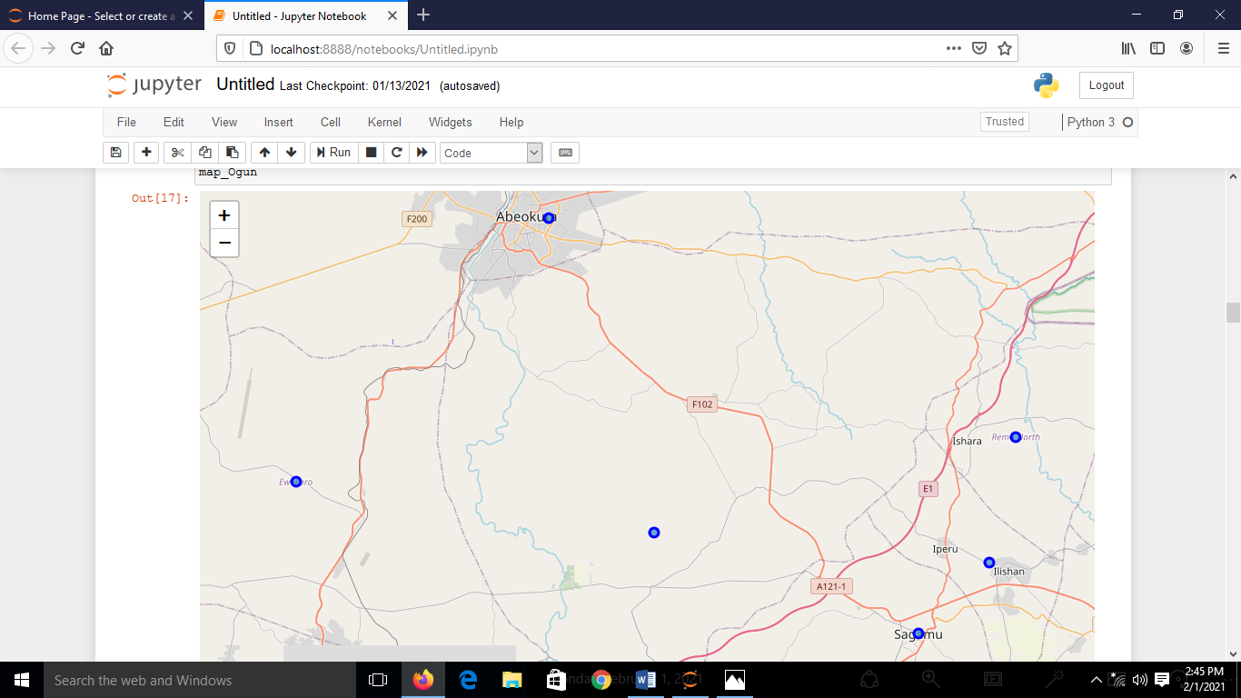

**DATA DESCRIPTION**

The dataset for the project is the Wikipedia page of Ogun state. It consists of all the local government areas(LGA) of the state as well as the population in each local government area in 2016. The data can obtained on the Wikipedia page: <https://en.wikipedia.org/wiki/List_of_Ogun_State_local_government_areas_by_population>.

**METHODOLOGY**

We shall begin by importing the following libraries: numpy, pandas, geopy, folium, requests and sklearn. Thereafter, the table on the Wikipedia page: <https://en.wikipedia.org/wiki/List_of_Ogun_State_local_government_areas_by_population> is read using pandas and html() function into a dataframe df1. It is further cleaned and processed into a dataframe df2 shown below.

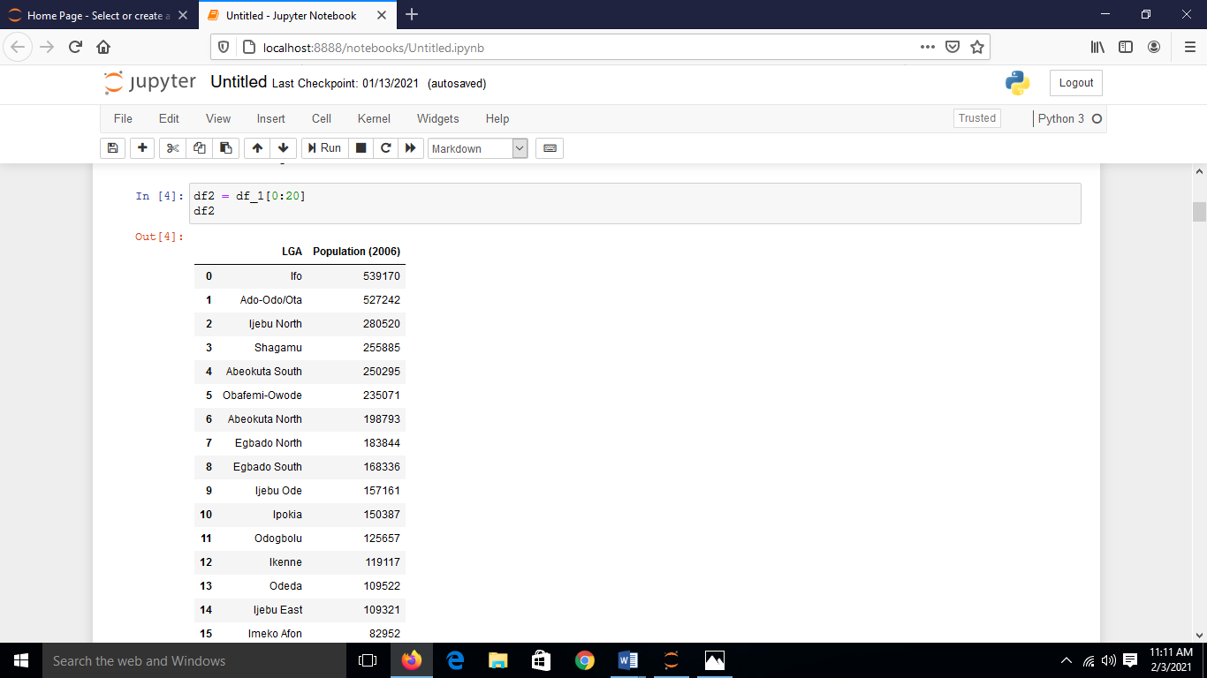

To obtain the longitude and latitude of each of the local government area of the state, Nominatim is imported from geopy.geolocator package and a user agent “ my explorer” is used to read the longititude and lataitude of each of the LGA in the dataframe df2. The following datatrame named Ogun_data is obtained. See the dataframe below.

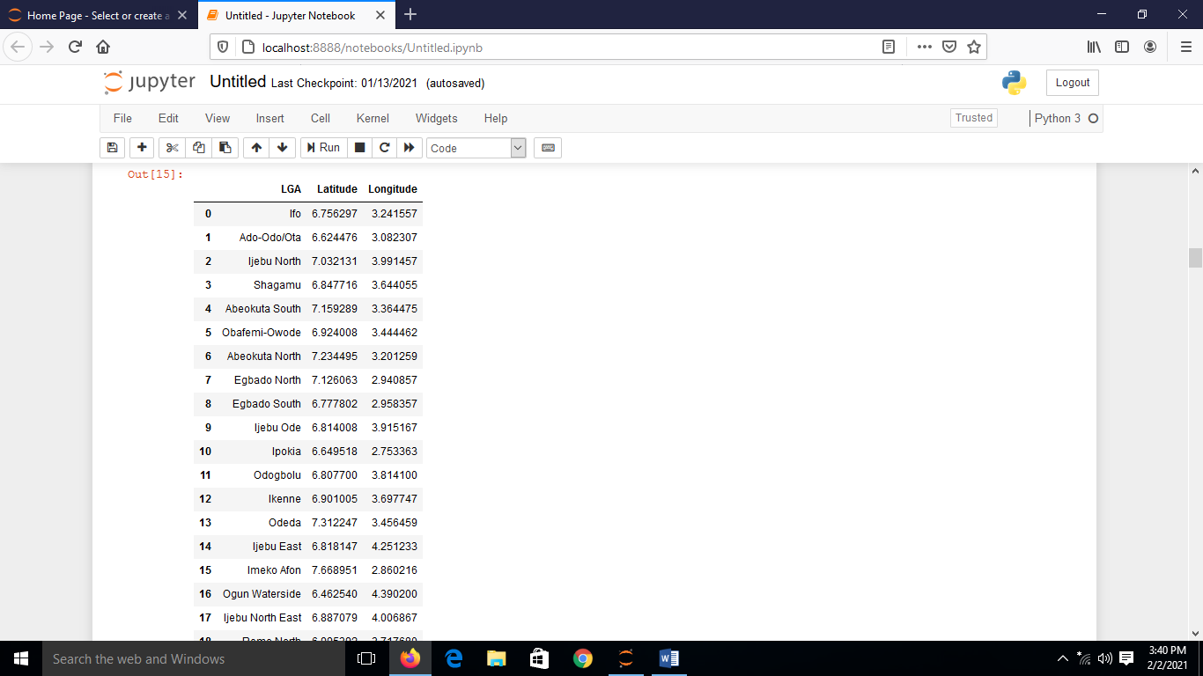

To get the nearby venues, we need to make foursquare api calls, to do this, we shall write a function getNearByVenues which has the following parameters:names, latitude, longitude and radius. The client_id, client_secret, version and limit = 100 are also supplied when making the foursquare api calls. Each local government area is explored at a radius of 20 km. Ogun_venues dataframe is obtained by passing as parameters the LGA name, latitude and longitude of the LGAs in Ogun_data dataframe. The Ogun_venues dataframe is shown below.

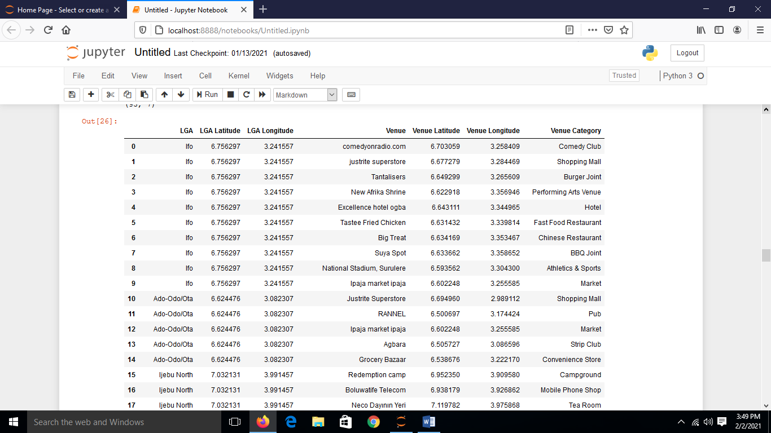

To obtain the most common venues in the state, a function return most common venues is written and it is used to get the top 10 common venues. The dataframe containing the top 10 common venues across the local government areas in the state is shown below.

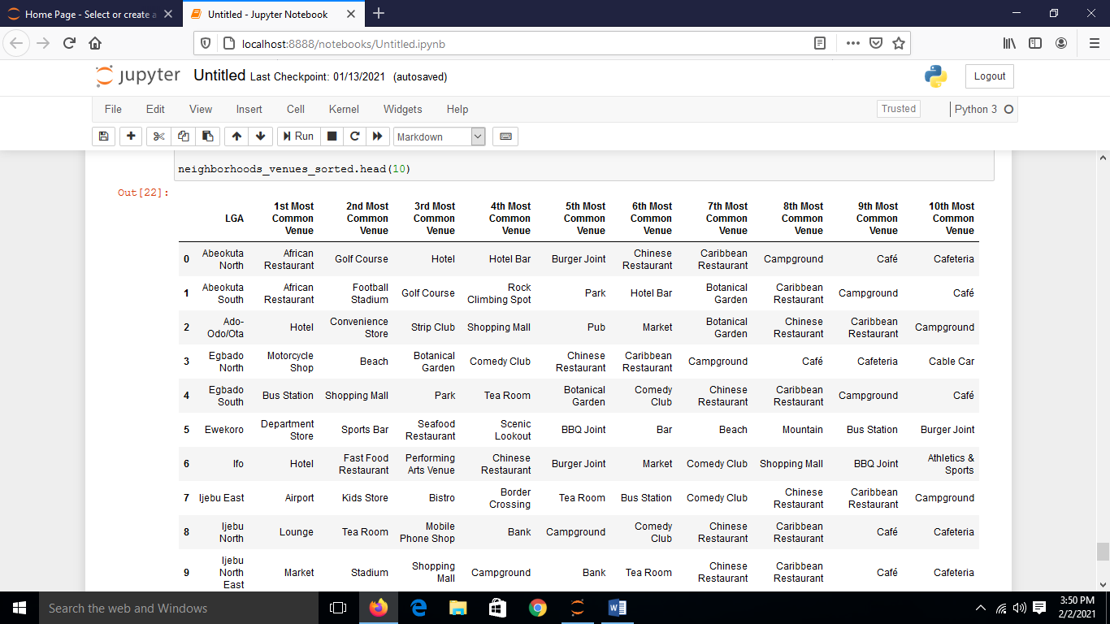

**RESULTS AND DISCUSSION**

The top 10 common venues in the various local government areas in the dataframe above shows the facilities available in those areas. Any neighbourhood of the state with transport facilities, hotels, banks, cafes, restaurants and airport will an ideal location for setting up a tourism business.

**CONCLUSION**

The local government area in the state that is most suitable for setting up a tourism business is Ijebu East local government area because it is the only local government area with airport facility as a common venue in addition to other facilities required for tourism.